Monolithic vs Microservices
What is Monolithic Architecture?
Monolithic Architecture is a software design approach where the entire application is built, developed, and deployed as a single unit.
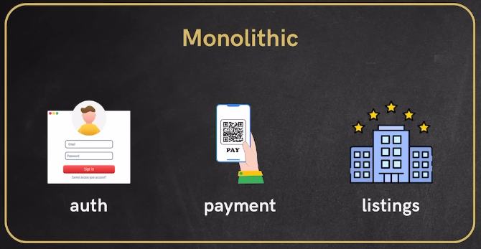
All modules such as authentication, payments, orders, notifications, and products exist
inside one codebase and are packaged together into a single deployable artifact such as:
- Single .jar (Java) /Single .war / Single .exe / Single Docker container
Develop as a single unit, deploy as a single unit — single CI/CD pipeline
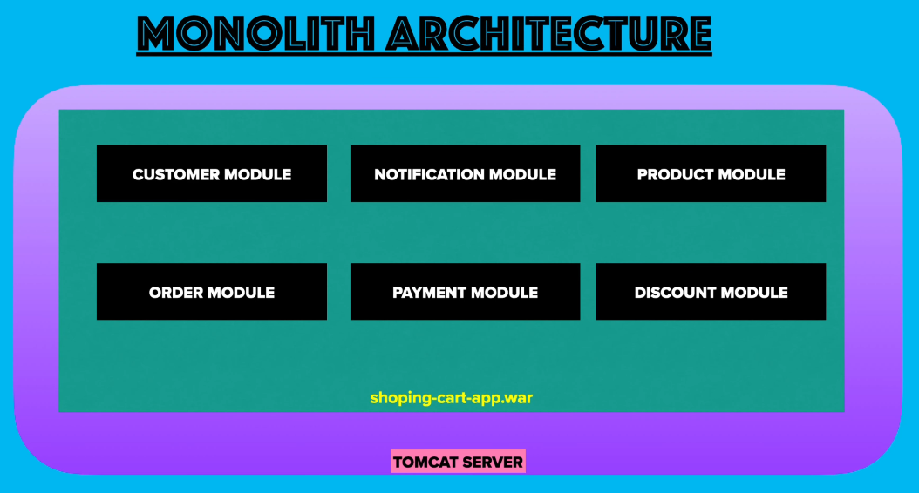

Monolithic Architecture Ecommerce Application
Consider an Ecommerce application like Amazon with the following modules:
- Customer Module
- Authentication Module
- Product Module
- Order Module
- Payment Module
- Notification Module
- Discount Module
In Monolithic architecture:
All these modules exist inside:
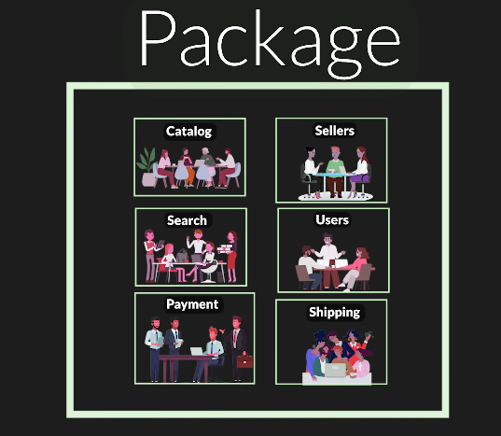
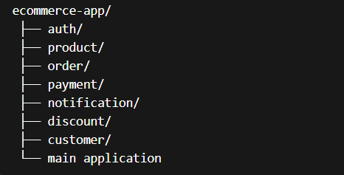
Everything runs as:
ecommerce.jar
Deployment:
Server → Run ecommerce.jar → Entire application runs
CI/CD:
Code change → Build entire app → Deploy entire app

How Development Works in Monolithic
Single repository Single codebase Single build pipeline
If developer updates:
Auth module password encryption logic
Entire application must be:
Rebuilt → Retested → Redeployed
Even though only one module changed.

How Deployment Works in Monolithic
Deployment unit:
Single Application Artifact
Example:
docker run ecommerce-app
All services run together.

Scaling in Monolithic Architecture
Scaling means handling more users or traffic.
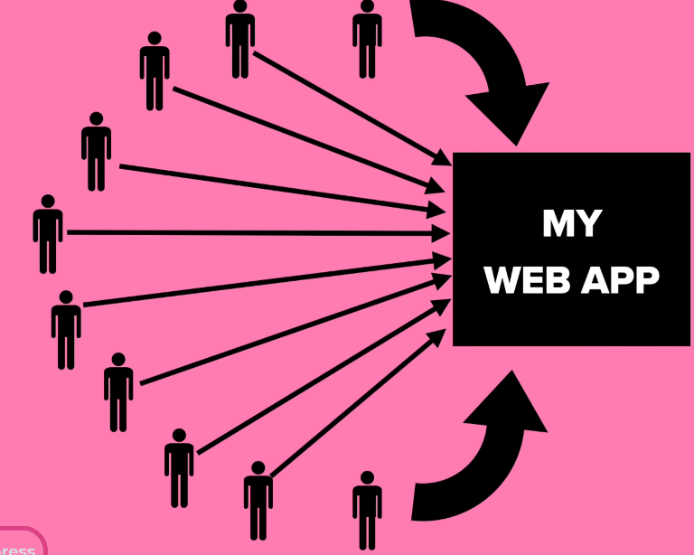
Vertical Scaling
Increasing server capacity.
Example:
Before:
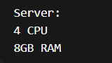
After scaling:
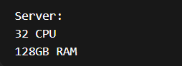
Problem:
- Expensive
- Hardware limit exists

Horizontal Scaling
Running multiple instances of same application.
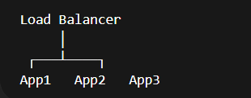
Each instance contains:
- Auth
- Payment
- Order
- Product
Even if only auth needs scaling Waste of resources.
Problems in Monolithic Architecture
1. Redeployment Problem
Example:
- Fix bug in Auth module.
Still must deploy entire app.
Process:
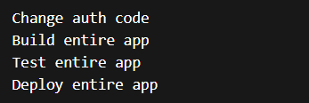
Time consuming & Risky.

2. Scaling Limitations
Example:
During signup campaign:
- Auth receives heavy traffic.
But cannot scale only auth.
Must scale entire application.
Wasteful.

3. Dependency Conflicts
Example:
Auth module needs:
Product module uses:
Since single application:
Must use same version.
Causes conflicts.

4. Tightly Coupled System
Modules depend heavily on each other.
Example:
Payment module directly calls order functions.
Changing order logic may break payment.
Hard to modify safely.

5. Slow Development in Large Teams
Ex : 1000 developers working on one codebase.
- Merge conflicts.
- Integration issues.
- Long build times.

6. Technology Lock-in
Entire application uses same tech stack.
Example:
- If built in Java:
- All modules must use Java.
- Cannot use Python for ML recommendation.

What is Microservices Architecture?
Microservices Architecture is a design approach where an application is divided into small, independent services, each responsible for specific business functionality.
Each service:
- Has independent codebase
- Has independent deployment
- Has independent database
- Communicates via APIs or messages
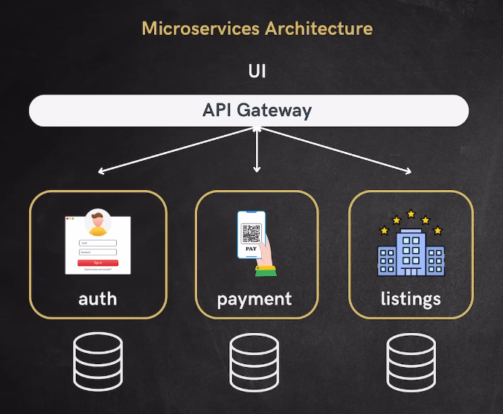

Ecommerce Application with Microservices
Instead of one application:
We create separate services:
- Auth Service
- Product Service
- Order Service
- Payment Service
- Notification Service
- Customer Service
- Discount Service
Each runs independently.
Example deployment:
- auth-service.jar
- payment-service.jar
- order-service.jar
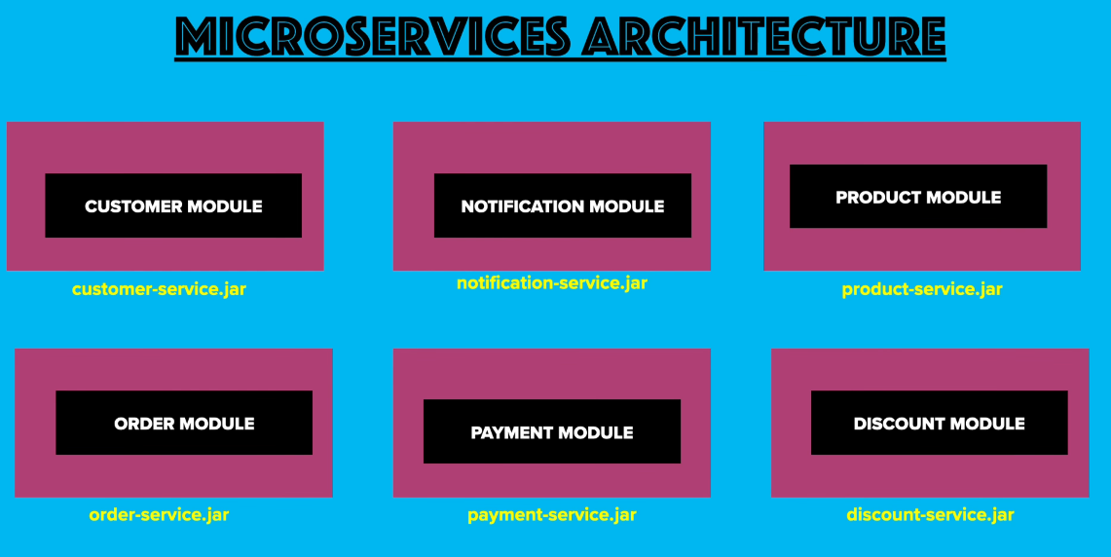
Each Service Has
Independent:
- Codebase
- Repository
- Team
- Deployment
- CI/CD pipeline
Example:
- Auth team deploys auth service.
- Payment team deploys payment service.
Independently.

How Ecommerce Flow Works in Microservices
Example: Customer buys product.
Step 1
Customer → Order Service
Step 2
Order Service → Payment Service
Step 3
Payment success → Notification Service
Step 4
Notification Service sends email
Each handled by different services.

How Microservices Communicate
Method 1: Synchronous Communication (REST API)
Service calls another service directly.
Example:
- Payment Service calls listings service.
- POST /listings/process
- Request → Response
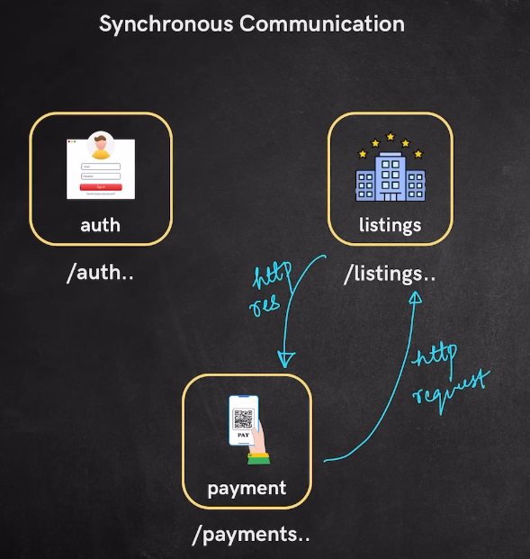
Each microservice will have individual endpoint
- Authentication /auth
- Payment /payment
- Listings /listings
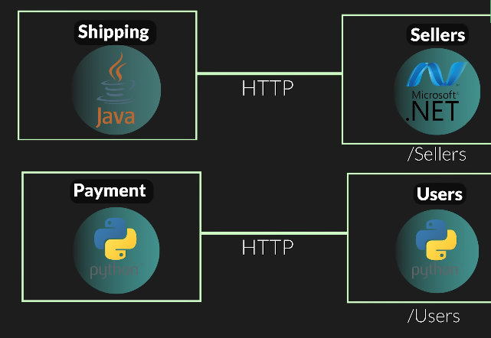
Method 2: Asynchronous Communication (Message Broker)
Services communicate using message broker.
Message brokers:
- Kafka
- RabbitMQ
- ActiveMQ
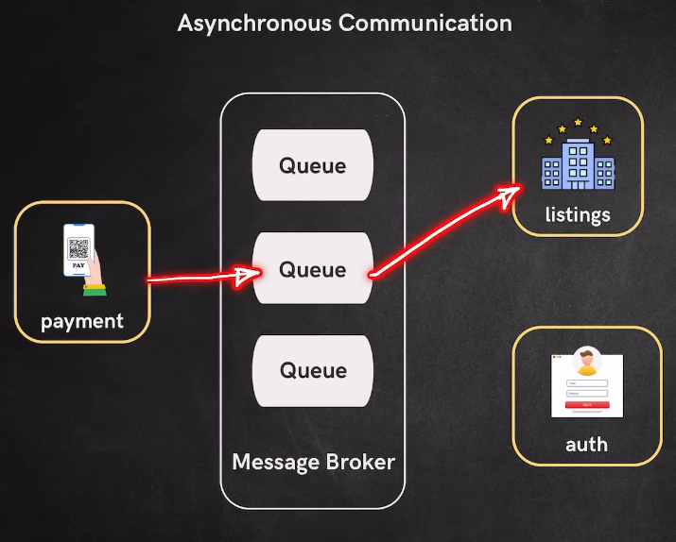
Example:
- Payment Service sends message:
- Payment done.
- Kafka stores message.
- Listings Service consumes message.
- Processes listings.
- No direct dependency.

Method 3: Service Mesh (Istio)
Used in Kubernetes.
Handles:
- Service discovery
- Security
- Routing
Automatically.

Scaling in Microservices
Example:
- During Big Billion Day sale.
Heavy load on:
- Order Service
Scale only Order Service, Not entire system.

Real Life Examples of Microservices
Taxi Booking App (Uber)
Services:
- User Service
- Driver Service
- Location Service
- Payment Service
- Notification Service
Booking flow:
- User Service → Booking Service
- Booking Service → Driver Service
- Driver accepts
- Payment Service processes payment
Money Transfer App
Services:
- Account Service
- Payment Service
- Fraud Service
- Notification Service
Transfer flow:
- User initiates transfer
- Payment Service processes
- Notification sent
Amazon Ecommerce Example
Services:
- User Service
- Catalog Service
- Search Service
- Cart Service
- Order Service
- Payment Service
- Shipping Service
Benefits of Microservices
1. Independent Deployment
Example:
  - Auth service version:
    - v1 → v2
  - Deploy only auth service.
  - No need to deploy payment service.
2. Technology Flexibility
- Search Service → Java
- Payment Service→ Python
- Sellers → .Net
Each service chooses best technology.
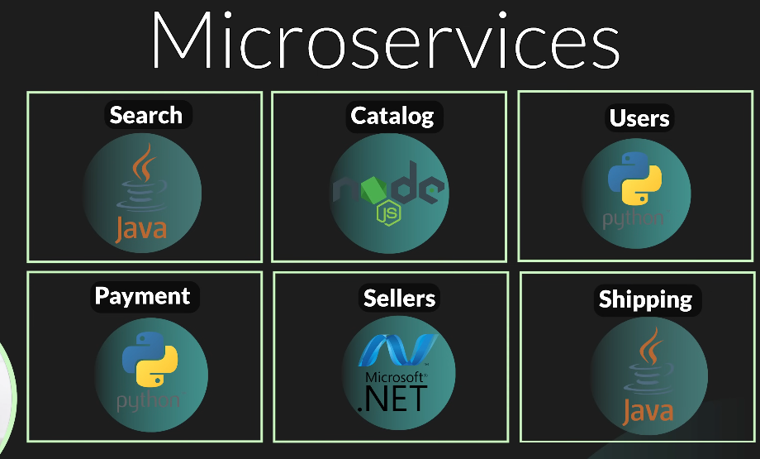

3. Independent Scaling
Example:
High login traffic.
Scale only auth service.
Not entire application.
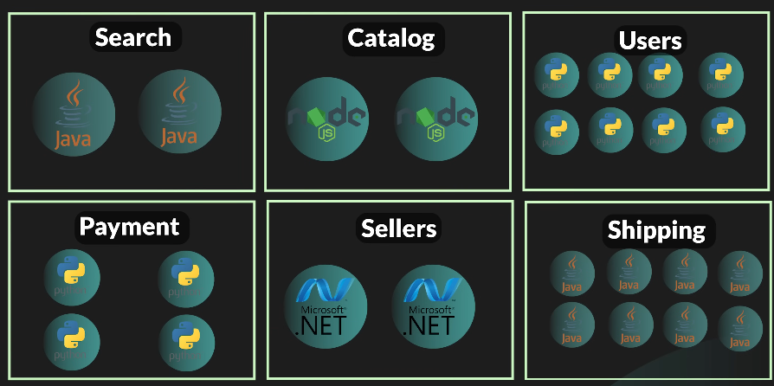

4. Faster Development
Teams work independently.
Parallel development possible.
5. Fault Isolation
If notification fails:
Payment still works.
System does not crash entirely.

Disadvantages of Microservices
1. Complex Architecture
- Multiple services.
- Hard to manage.
2. Infrastructure Cost
Need:
- Servers
- Containers
- Networking
- Higher cost.
3. Debugging Difficulty
- Request flows across many services.
- Harder debugging.
4. Requires Skilled Teams
Not suitable for small startups.

Migration from Monolithic to Microservices
1: Does each file become microservice?
NO, Microservices are based on BUSINESS FUNCTION, not files.
Example:
Auth service contains:
- Login
- Register
- JWT
- User validation
All grouped into one service.
Not separate services for each file.
2: How many microservices should we create?
There is NO fixed number.
Depends on:
- Business requirements
- Team structure
- System complexity
Example Ecommerce microservices:
- Auth Service
- Product Service
- Order Service
- Payment Service
- Notification Service
Large companies may have 500+ services.
Small companies may have 5 services.

3: How to restructure codebase?
Monolithic:

Microservices:

Separate repositories.
Separate deployments.
4: How services communicate?
In Monolithic:
Communication via function calls:
In Microservices:
Communication via:
HTTP REST API
Example:

When to Use Monolithic
- Small applications
- Small teams
- Simple systems
Example:
Startup MVP
When to Use Microservices
- Large applications
- Large teams
- High traffic systems
Example:
- Amazon
- Netflix
- Uber
Monolithic architecture builds and deploys the entire application as a single unit, making it simpler but difficult to scale and maintain at large scale.
Microservices architecture divides the application into independent services, enabling independent deployment, scaling, and technology flexibility, but introduces infrastructure and operational complexity.
Modern large-scale systems like Amazon, Netflix, and Uber use microservices to handle millions of users efficiently.
Feature | Monolithic | Microservices
Deployment | Single unit | Independent
Scaling | Entire app | Individual service
Development | Single codebase | Multiple codebases
Flexibility | Low | High
Complexity | Low | High
Best for | Small teams | Large systems

Important Design Patterns in Microservices Architecture

Microservices architecture introduces flexibility and scalability, but it also introduces complexity. To manage this complexity, several design patterns are used. These patterns help define clear service boundaries, enable communication, manage deployment, and ensure scalability and reliability.

1. Domain Driven Design (DDD) Pattern
Domain Driven Design (DDD) is a design approach used to define clear boundaries for each microservice based on business functionality (domain).
Each microservice represents a specific business capability and contains only the logic related to that domain.
Each microservice should focus on one business responsibility only.

Why DDD is Important in Microservices
In microservices, improper separation can cause confusion and tight coupling.
DDD ensures:
- Clear ownership of services
- Independent development
- Easier scalability
- Easier maintenance
Example rule:
- Email notification logic should NOT exist inside the Payment service.
- Order processing logic should NOT exist inside the Authentication service.
Each service must handle only its own responsibility.

Ecommerce Example using DDD
Microservices division:
- Authentication Service → login, register, JWT validation
- Product Service → product listing, search
- Order Service → create order, track order
- Payment Service → process payments, refunds
- Notification Service → email, SMS notifications
Example flow when placing an order:
- User clicks "Place Order"
- Order Service creates order
- Order Service calls Payment Service
- Payment Service processes payment
- Notification Service sends confirmation
Each service performs only its own responsibility.
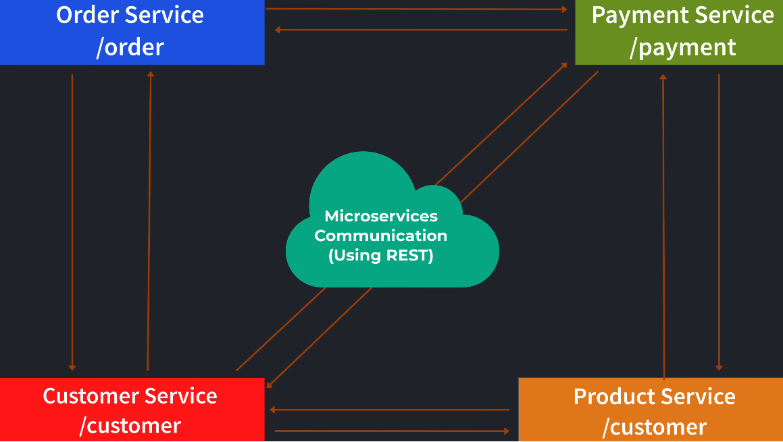

Loan Application Example using DDD
Consider a banking loan application.
Instead of building one large system, we divide it into domain-specific services:
- Auto Loan Service → handles car loan applications
- Home Loan Service → handles home loan processing
- Recovery Service → handles loan recovery
- Agent Service → manages loan agents
Each service has its own:
- Codebase
- Database
- Deployment
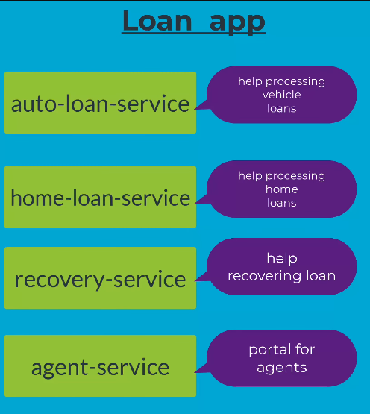

Key Principle of DDD
Define clear Bounded Context
Bounded context means Each service owns its domain completely.
Payment service handles Payment processing Refunds
It does NOT handle:
- Order creation
- Email sending

Domain Knowledge Requirement
Microservices developers must understand the business domain clearly.
Example:
If building Payment Service, developer must understand:
- Payment flow
- Payment status
- Refund logic
Without domain knowledge, incorrect service boundaries may be created.

2. Service Discovery and Registration Pattern
Problem
In microservices, services run on:
- different Servers
- different IP addresses
- different Ports
Example:
- Order Service → 10.0.0.2:8080
- Payment Service → 10.0.0.5:9090
- Product Service → 10.0.0.7:8085
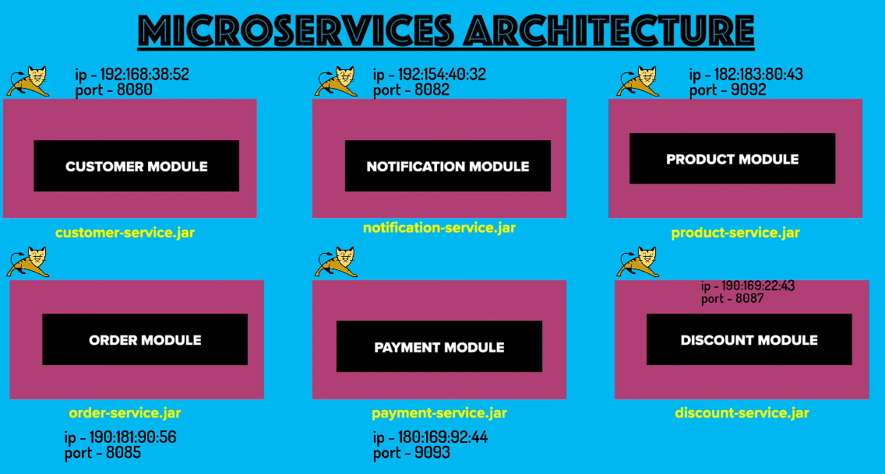
If Order Service wants to call Payment Service, how does it know:
- IP address?
- Port number?
Hardcoding is not possible because services scale dynamically.
Solution: Service Discovery
Service Discovery is a system that stores and provides the location of all services.
It acts like a phone directory of microservices.
Examples:
- Eureka
- Consul
- Kubernetes Service Discovery
How Service Registration Works
When a microservice starts, it registers with Discovery Service.
It provides:
- Service Name
- IP Address
- Port
Example:
Payment Service registers → 10.0.0.5:9090
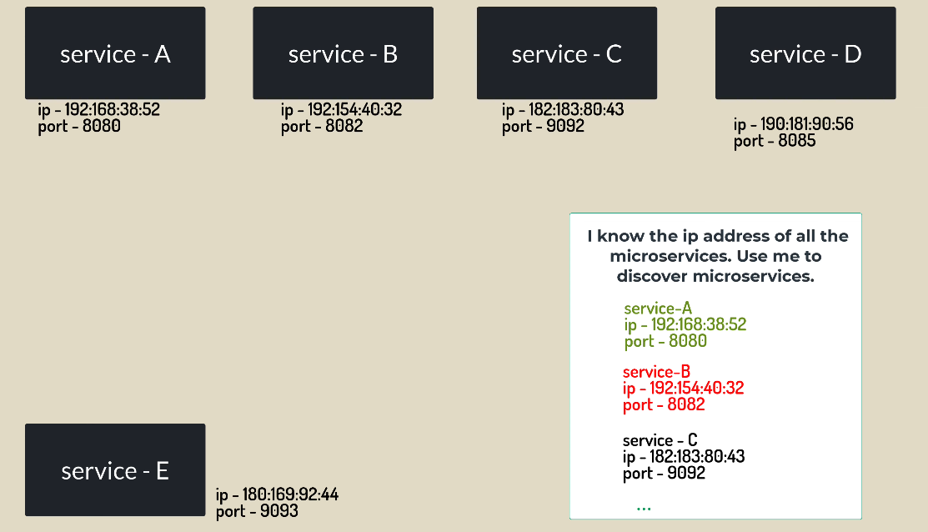
How Service Discovery Works
Example:
Order Service wants to call Payment Service.
Step 1
Order Service asks Discovery Service "Where is payment-service?"
Step 2
Discovery Service returns 10.0.0.5:9090
Step 3
Order Service calls Payment Service.
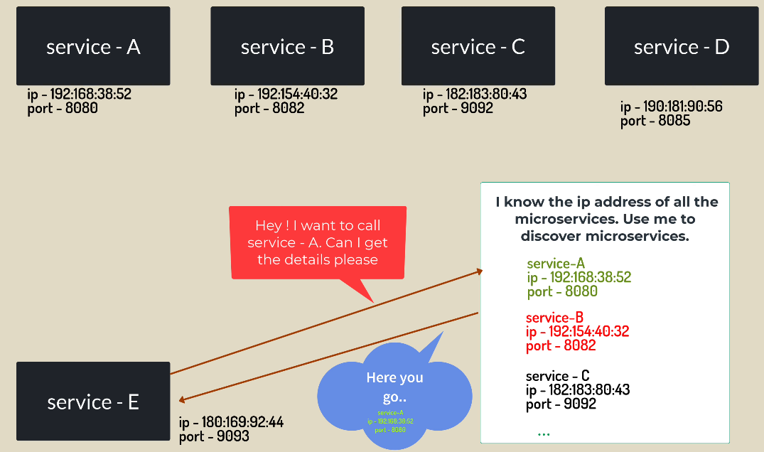
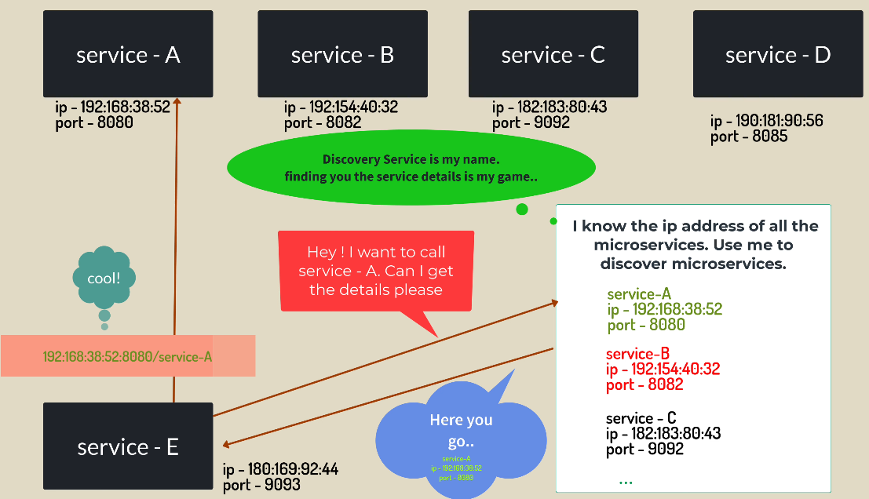
3. Microservice Communication using Message Brokers
Previously, services communicated directly using REST APIs.
But direct communication creates tight dependency.
Solution:
Message Broker
Message broker acts as a middleman between services.
Instead of calling directly, services send messages to brokers.
Broker forwards message to destination service.
Common Message Brokers:
- Apache Kafka
- RabbitMQ
- ActiveMQ
- Apache Artemis

4. Message Broker Pattern
Message Broker is a system that enables asynchronous communication between microservices using messages.
Instead of direct communication:
Service → Message Broker → Destination Service
Example Ecommerce Flow
- Order Service creates order.
(Instead of calling Payment Service directly)
- Order Service sends message to Kafka "Order Created"
- Kafka stores message.
- Payment Service reads message.
- Processes payment.

Producer and Consumer Concept
Producer Service sending message.
Ex: Order Service
Consumer Service receiving message.
Ex: Payment Service

5. Event Streaming Pattern
What is an Event?
An event represents something that happened in the system.
Examples in Ecommerce:
- Order created
- Payment completed
- Item shipped
- Out for delivery
- Refund initiated
Each of these is an event.
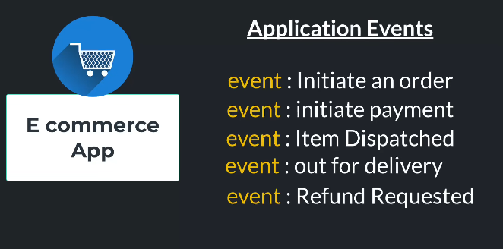

How Event Streaming Works
Services publish events to Message Broker.
Example:
- Order Service publishes event:
- Order Shipped
- Kafka receives event
- Notification Service consumes event
- Customer receives notification
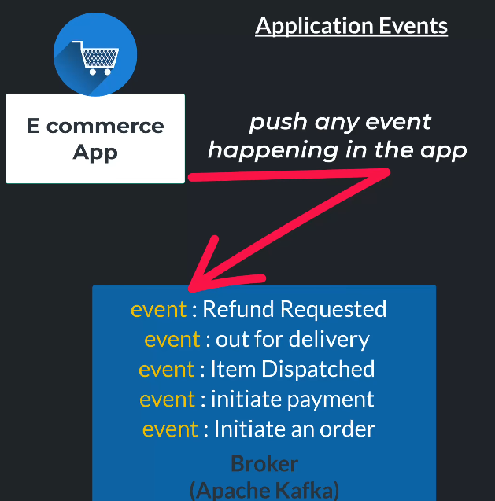
Benefits:
- Loose coupling
- High scalability
- Real-time processing

6. Database Design Pattern in Microservices
Monolithic Database Design
Single database used by entire application.
Example:
ecommerce_db
Tables:
- Users
- Orders
- Payments
- products
All modules access same database.
Problem:
- Tight coupling
- Scaling difficulty

Microservices Database Design
Each microservice has its own database.
Example:
- Auth Service → auth_db
- Order Service → order_db
- Payment Service → payment_db
Benefits:
- Independent scaling
- Data isolation
- Improved reliability
Example:
- Payment Service failure does not affect Order database.

7. Microservice Deployment using Docker and Kubernetes
Each microservice is packaged into a container using Docker.
Example:
auth-service → Docker container
payment-service → Docker container
Docker ensures consistent environment.
Kubernetes manages:
Deployment
Scaling
Load balancing
Health monitoring
Example:
If Payment Service receives heavy traffic, Kubernetes automatically creates more instances.

8. Load Balancer Pattern
Problem
If one service instance receives too much traffic, it becomes overloaded.
Example:
Order Service running on:
- Server 1
- Server 2
- Server 3
Users must be distributed across servers.

Solution: Load Balancer
Load Balancer distributes traffic evenly across service instances.

Architecture:
User Request
↓
Load Balancer
↓
Server 1
Server 2
Server 3

Example Ecommerce Application:
During sale:
Millions of users place orders.
Load balancer distributes requests across multiple Order Service instances.
Prevents system crash.
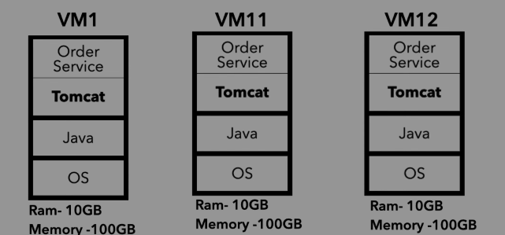
Benefits
- Improved performance
- High availability
- Fault tolerance
If one server fails, load balancer redirects traffic to others.

Summary
Key microservice patterns include:
- Domain Driven Design → defines service boundaries
- Service Discovery → helps services find each other
- Message Brokers → enable asynchronous communication
- Event Streaming → enables real-time event processing
- Database per Service → ensures isolation
- Docker & Kubernetes → manage deployment and scaling
- Load Balancer → distributes traffic efficiently
These patterns enable microservices to be scalable, flexible, and reliable in large-scale production systems.

